**React Router Introduction**

We use routing in the web applications because we have multiple pages in the website because each page contains its owns section or set of contents.

For example, take **leetcode** platform there we **have dicussions page, problems page, or your profile page** when you click it everything has its **own set of details** or instructions.so it is achieved through **routing**.

**Web Routing:**

* Web routing is the process of mapping a URL to the correct code that handles that request, directing users to the right page or resource on a website.
* It can be handled on the [**server-side**](https://www.google.com/search?q=server-side&rlz=1C1RXQR_enIN1171IN1171&oq=web+routing&gs_lcrp=EgZjaHJvbWUyCQgAEEUYORiABDIICAEQABgWGB4yCAgCEAAYFhgeMggIAxAAGBYYHjIICAQQABgWGB4yCAgFEAAYFhgeMggIBhAAGBYYHjIICAcQABgWGB4yCAgIEAAYFhgeMggICRAAGBYYHtIBCTYyNDlqMGoxNagCCLACAfEFGH8Y7XyO5dk&sourceid=chrome&ie=UTF-8&mstk=AUtExfCNL2pkgq7-PQ2gCaanDFswWIhUth-GtMQrDVKta7_A7rdzWuwr64O_nwK2h-cLpoTTmNmtLIAeuJWjaqTL-8s4PxGFx3q8Ms0xyiVfSiBR0BZVkJ6aUSoNLJoIWiCB260n_mghaDhHvHJT1hILfnjzvEaX3_Xy5B_5trqLmvcnPLg&csui=3&ved=2ahUKEwj3iaKRyMaQAxXW1zQHHd-THNgQgK4QegQIARAC), where the server sends a specific file or page based on the URL, or on the [**client-side**](https://www.google.com/search?q=client-side&rlz=1C1RXQR_enIN1171IN1171&oq=web+routing&gs_lcrp=EgZjaHJvbWUyCQgAEEUYORiABDIICAEQABgWGB4yCAgCEAAYFhgeMggIAxAAGBYYHjIICAQQABgWGB4yCAgFEAAYFhgeMggIBhAAGBYYHjIICAcQABgWGB4yCAgIEAAYFhgeMggICRAAGBYYHtIBCTYyNDlqMGoxNagCCLACAfEFGH8Y7XyO5dk&sourceid=chrome&ie=UTF-8&mstk=AUtExfCNL2pkgq7-PQ2gCaanDFswWIhUth-GtMQrDVKta7_A7rdzWuwr64O_nwK2h-cLpoTTmNmtLIAeuJWjaqTL-8s4PxGFx3q8Ms0xyiVfSiBR0BZVkJ6aUSoNLJoIWiCB260n_mghaDhHvHJT1hILfnjzvEaX3_Xy5B_5trqLmvcnPLg&csui=3&ved=2ahUKEwj3iaKRyMaQAxXW1zQHHd-THNgQgK4QegQIARAD), where a JavaScript framework dynamically updates the content of a single-page application without a full page reload.

React Routing:

* React routing, primarily handled by the React Router library, is the mechanism that enables navigation between different views or "pages" within a single-page application (SPA) built with React.
* Unlike traditional multi-page applications where a full page reload occurs for each new view, React Router allows for seamless and dynamic updates to the UI without a complete page refresh.

**Server side routing:**

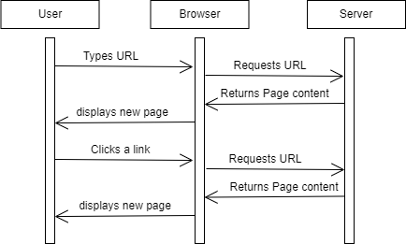

**Client side routing:**

* Client-side routing is a technique used in web development, particularly in Single Page Applications (SPAs), to manage navigation within a website without requiring a full page reload from the server.
* Instead of the server handling every route change, JavaScript running in the user's browser takes control.

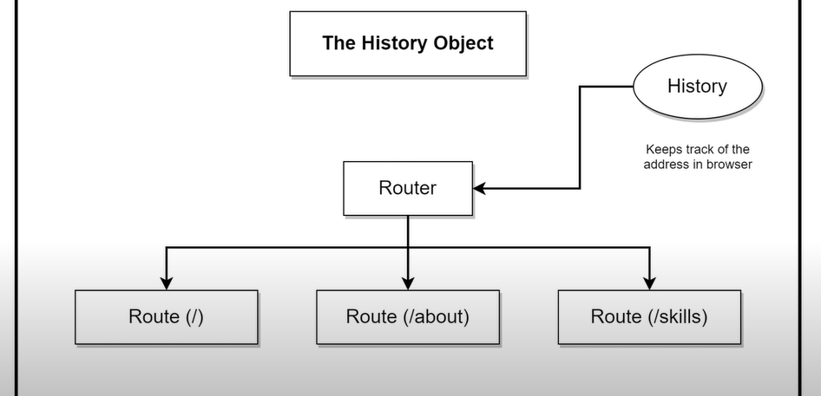

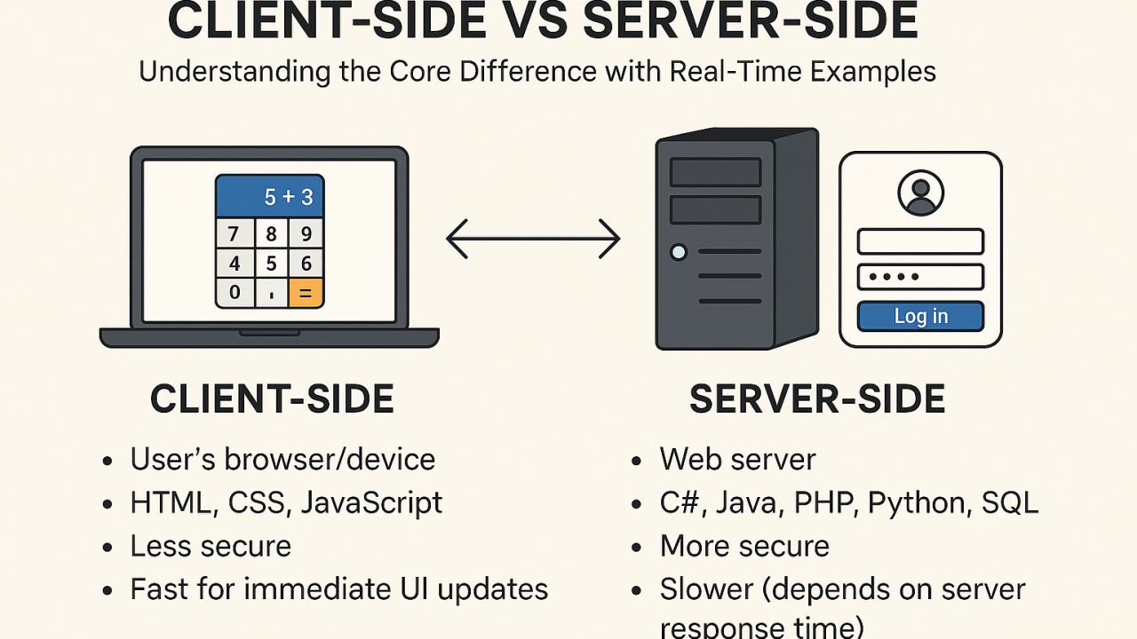

**Examples you can take:**

**Srever side routing :**

Wikipedia website when you click other links on Wikipedia page it will refresh the page and generate a new html of that particular link data and gives back to us.

**Client side routing:**

Leetcode,It follows both client side routing and the server side routing.we will see the client side routing.

In there go to discuss page in navbar and in that page you will some other headings like interview questions sections, etc.., .When you observe the page will not reload the page but it will gives that particular section data because it will render conditionally on browser only.

**Pros and cons:**

